**Assignment-5**

**Create a public bucket in AWS. Upload a file and give the necessary permission to check the file URL is working or not.**

## Part 1: Create a Public Bucket

1. **Sign in to AWS**:
   * Log in to the **AWS Management Console**.
   * 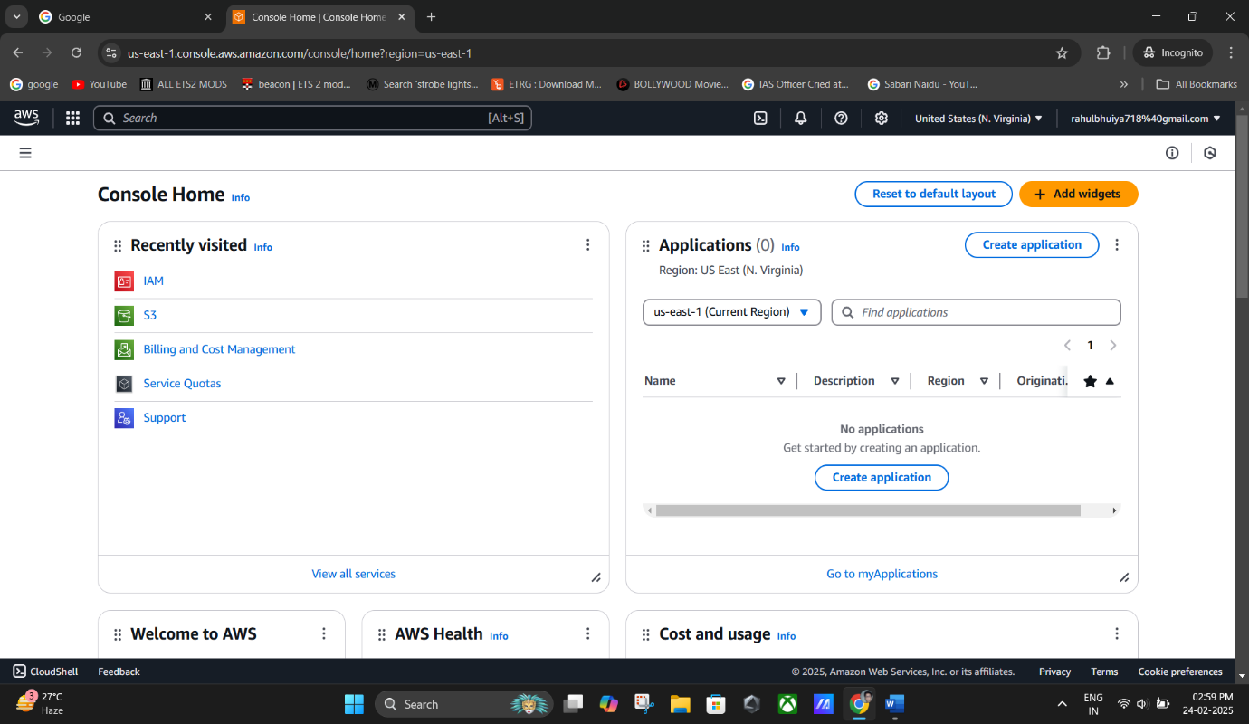Navigate to the **Amazon S3 Console**.

## Navigate to Buckets:

* + 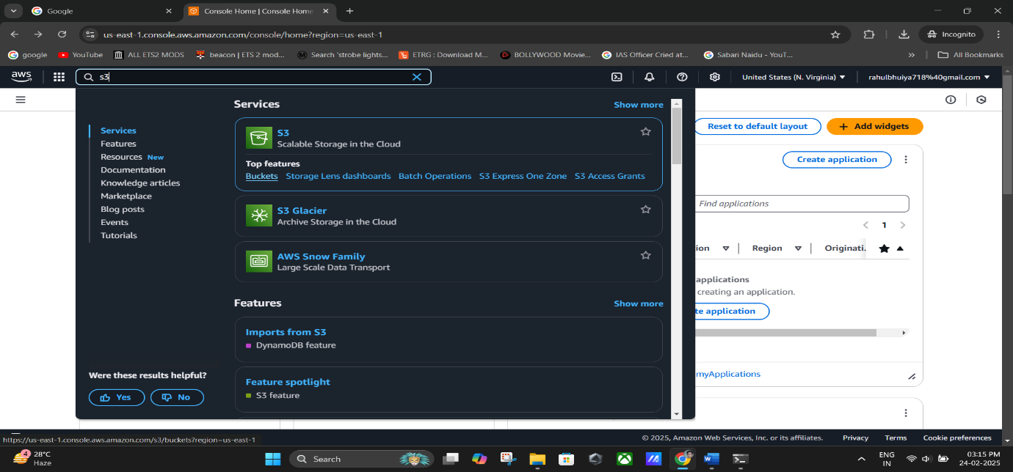From the left-hand menu, select **Buckets**.

## Create a Bucket:

* + Click **Create bucket**.
  + On the **Create bucket** page:
    - **Bucket Name**: Enter a unique name for your bucket (e.g.,

rahulbhuiyabucket).

* + - 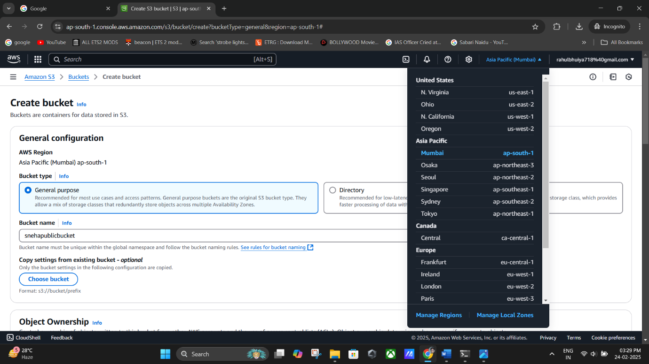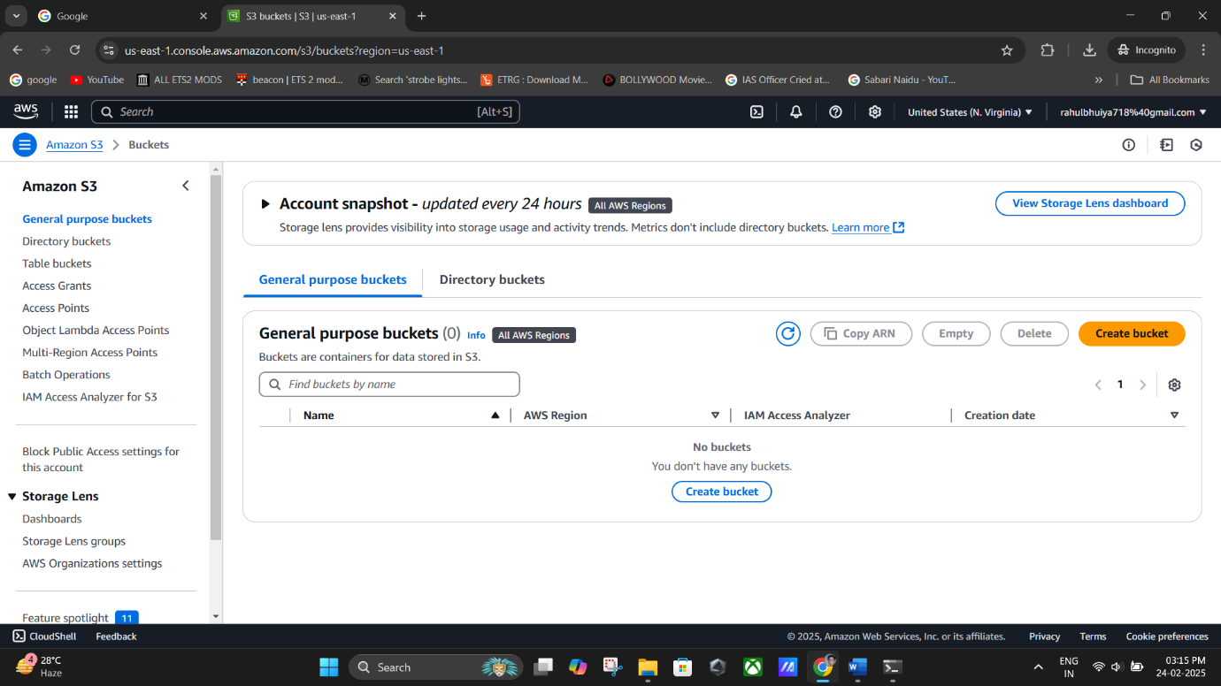**Region**: Select your preferred AWS Region.

**(Create Bucket).**

## Set Object Ownership:

* + Under **Object Ownership**, enable **ACLs** to control ownership of uploaded objects.

## Choose Bucket owner enforced – ACLs enabled.

**(ACLs enabled).**

1. Adjust Public Access Settings:
   * Uncheck the **Block Public Access settings for this bucket** checkbox.
   * 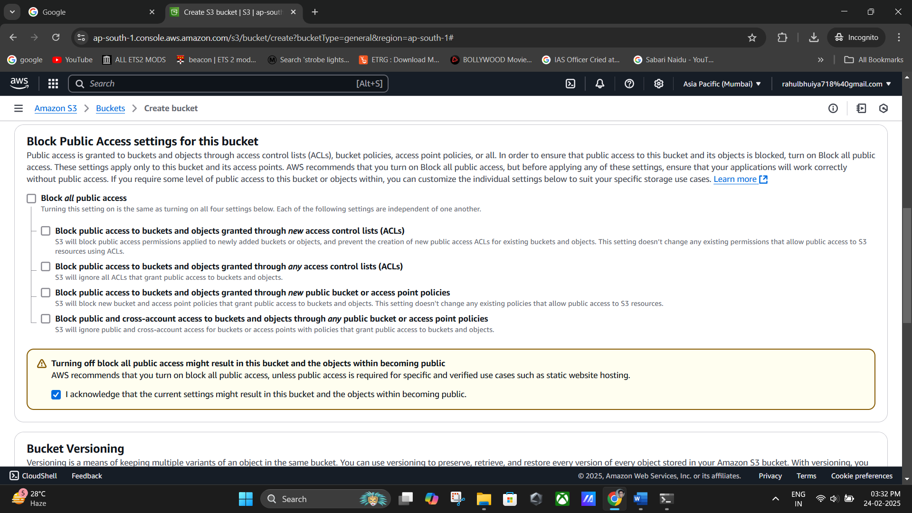Tick the acknowledgment box confirming your choice.

**(Unchecking the “Block Public Access Settings”)**

## Create the Bucket:

* + 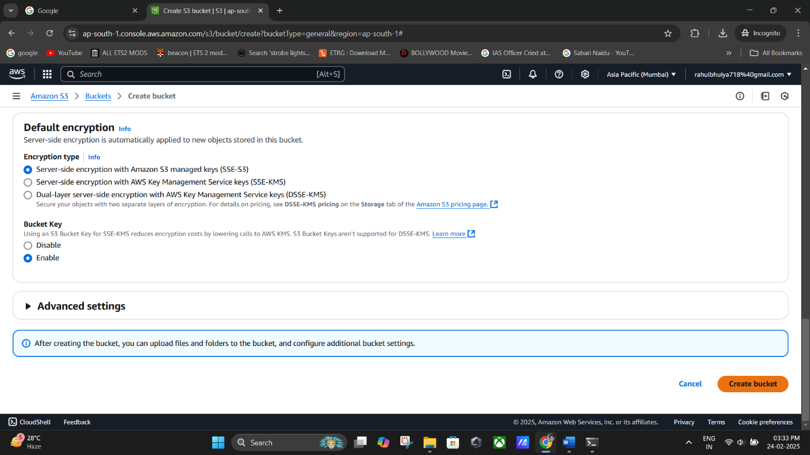Click **Create Bucket** to finalize the process.

**(Creating Bucket).**

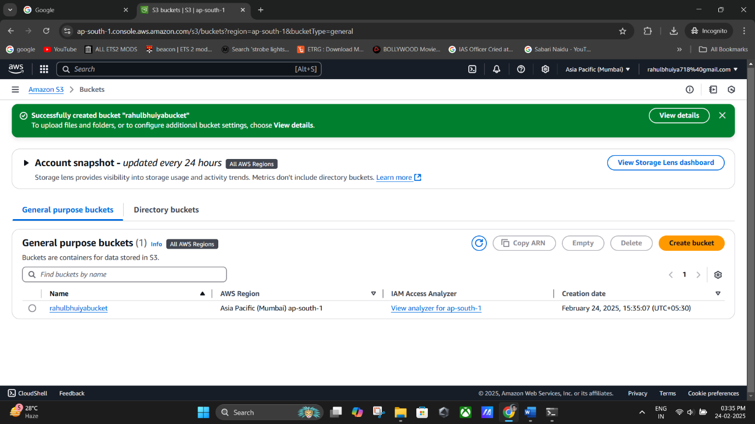

**(Bucket Created Successfully).**

## Part 2: Upload Files and Grant Public Access

1. **Open the Bucket**:
   * After creation, locate your bucket in the list and click its name.



**(Locating our “Bucket” in the list).**

## Upload Files:

* + Within the bucket, click **Upload**.
  + On the upload page, click **Add files** and select the file(s) to upload.
  + 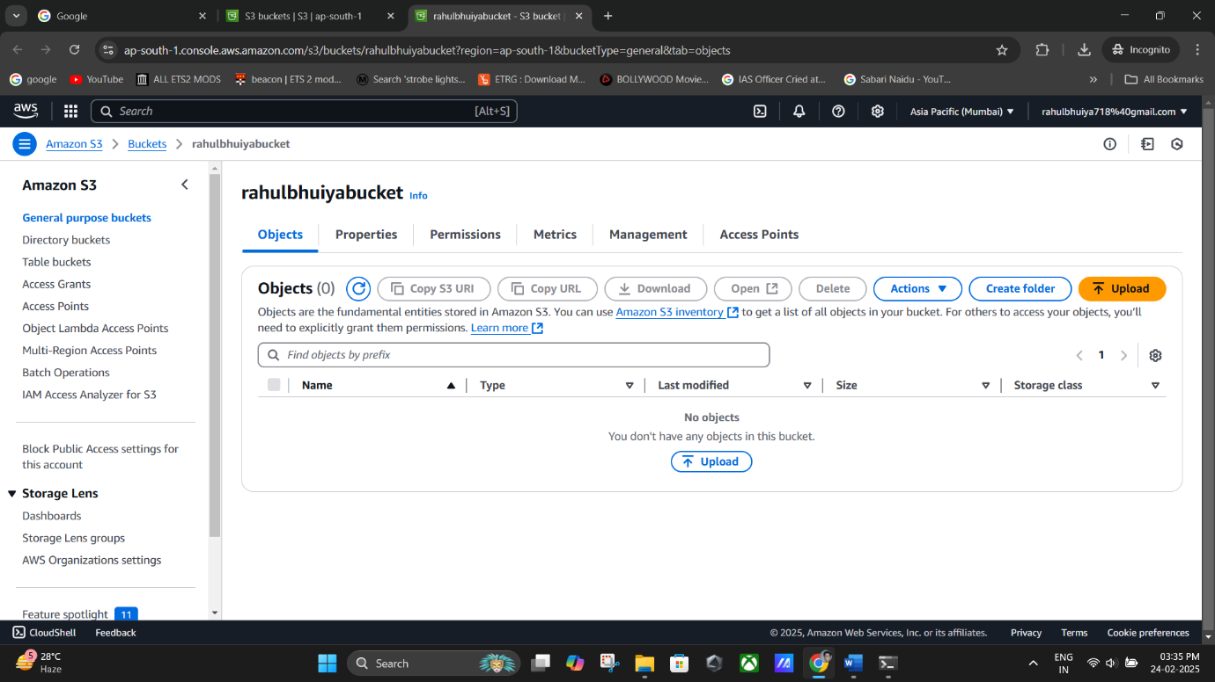Click **Upload** to complete the process.

**(Upload).**

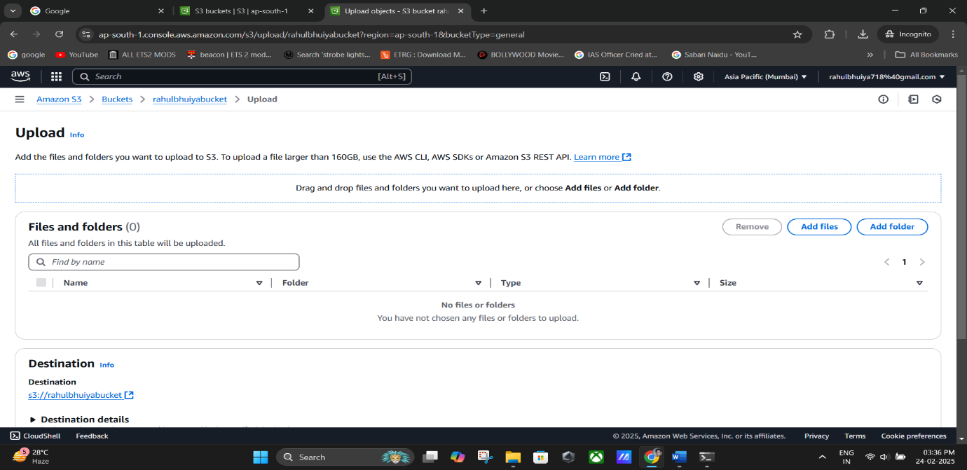

## 

**(Upload process completed).**

## Set Permissions for Uploaded Files:

* + Select the uploaded file and navigate to the **Permissions** tab.
  + 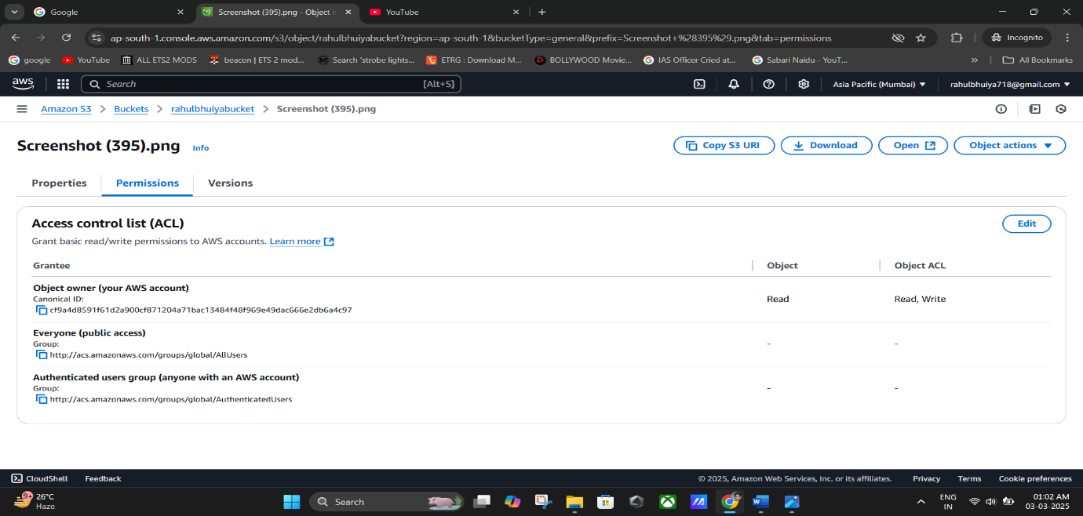Under **Access Control List (ACL)**, click **Edit**.

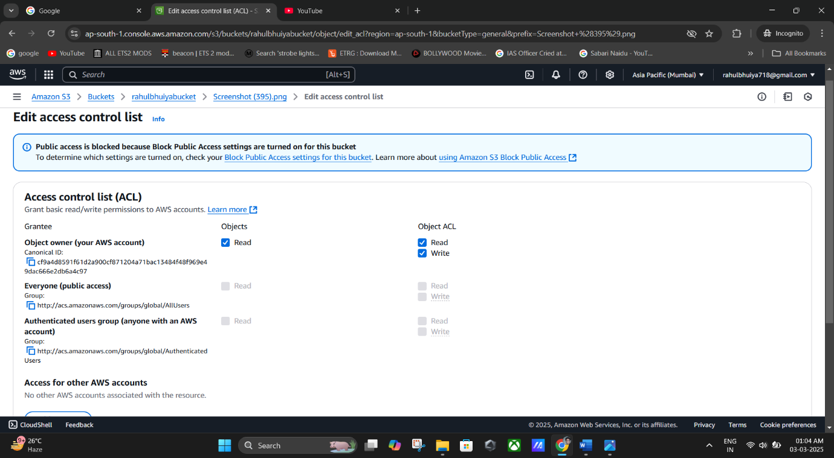

## Grant Public Access:

* + Check the **Read permission** boxes for **Object** and **Object's ACL** under

## Everyone (public access).

* + Tick the acknowledgment box confirming you understand the changes.
  + 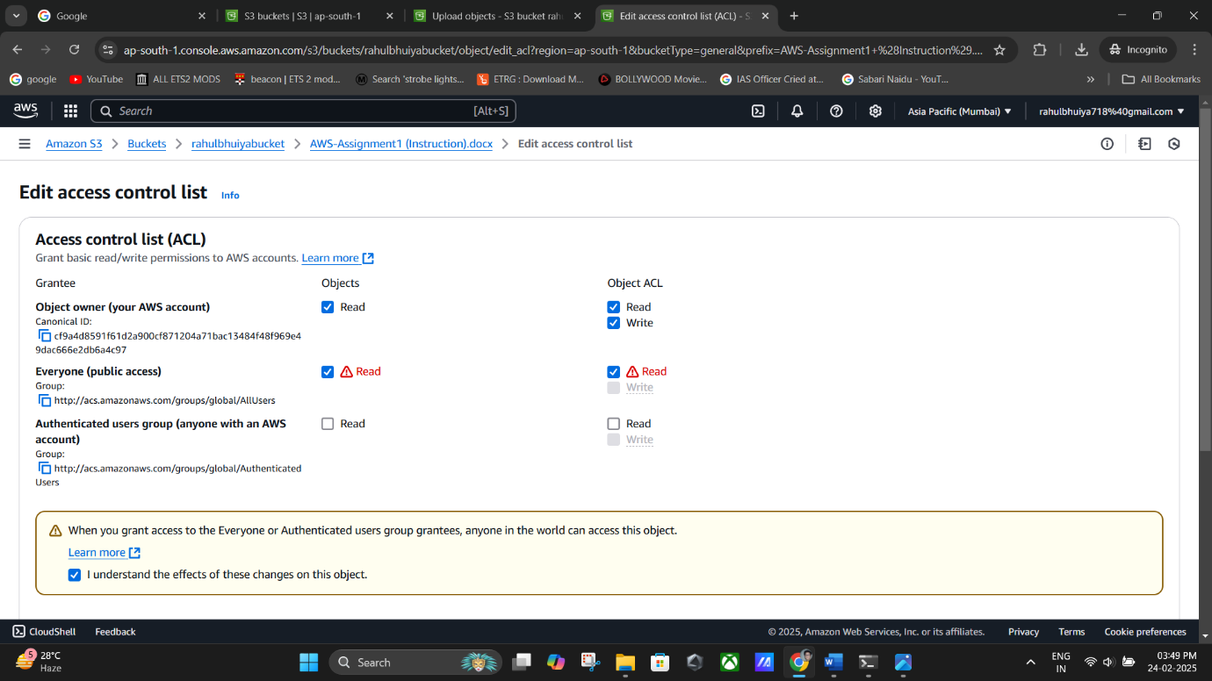Click **Save changes**.

**Everyone (Public Access).**

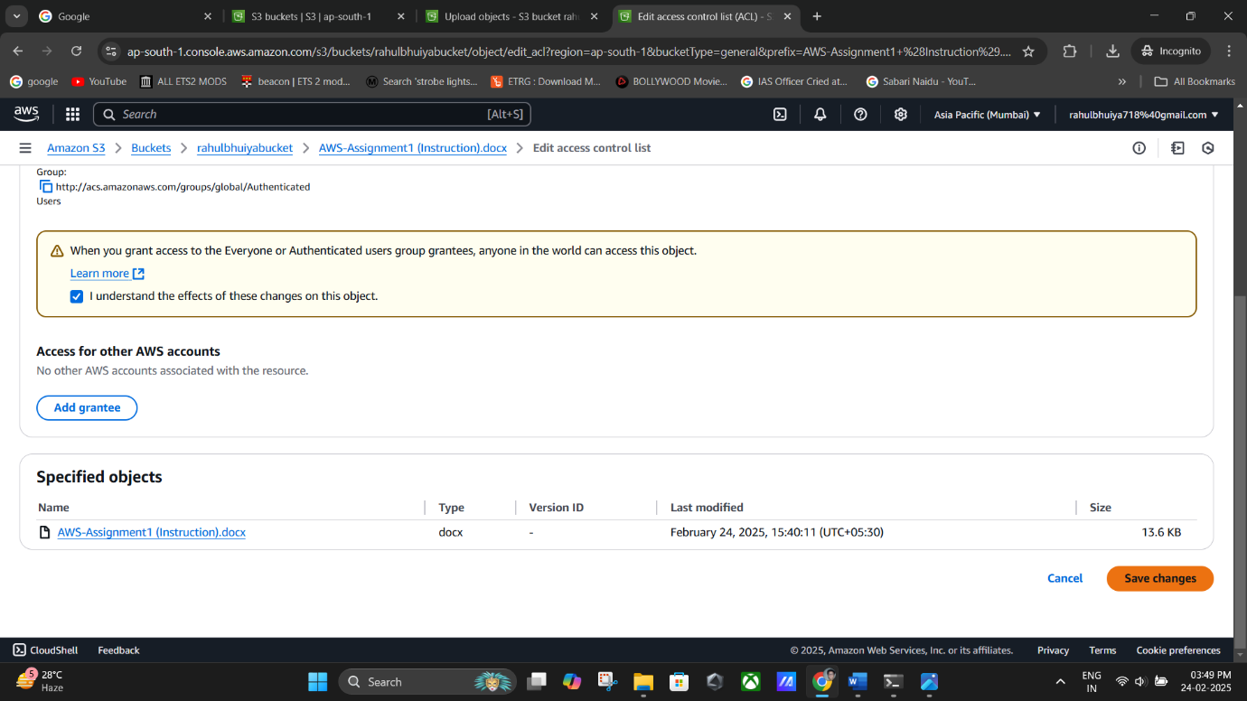

**(Saving Changes).**

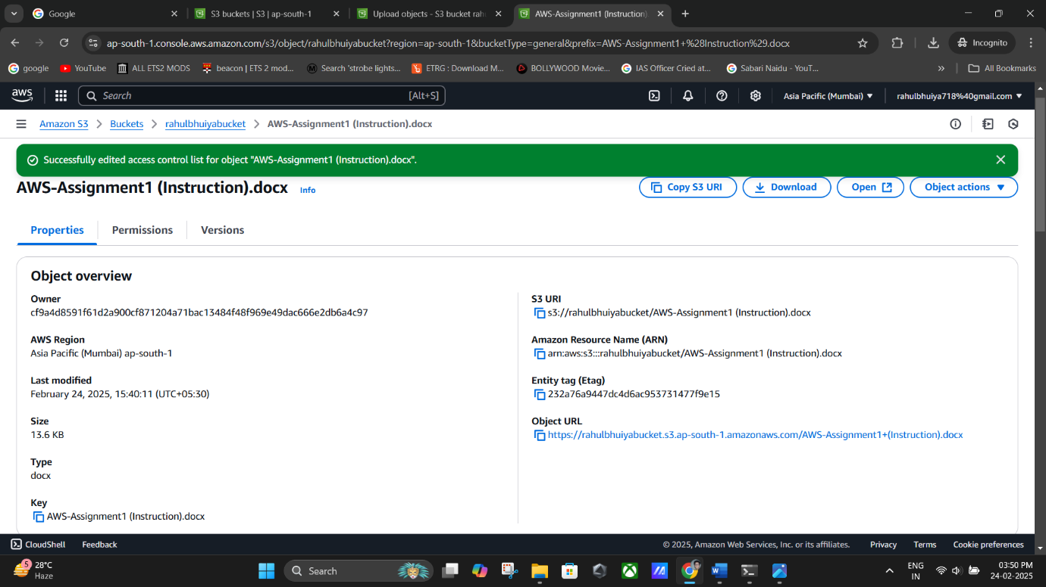

**(Successfully Edited Access Control).**

## Verify Public Access:

* + Go to the **Properties** tab of the uploaded file.
  + Copy the **Object URL**.
  + Paste the URL into a web browser.

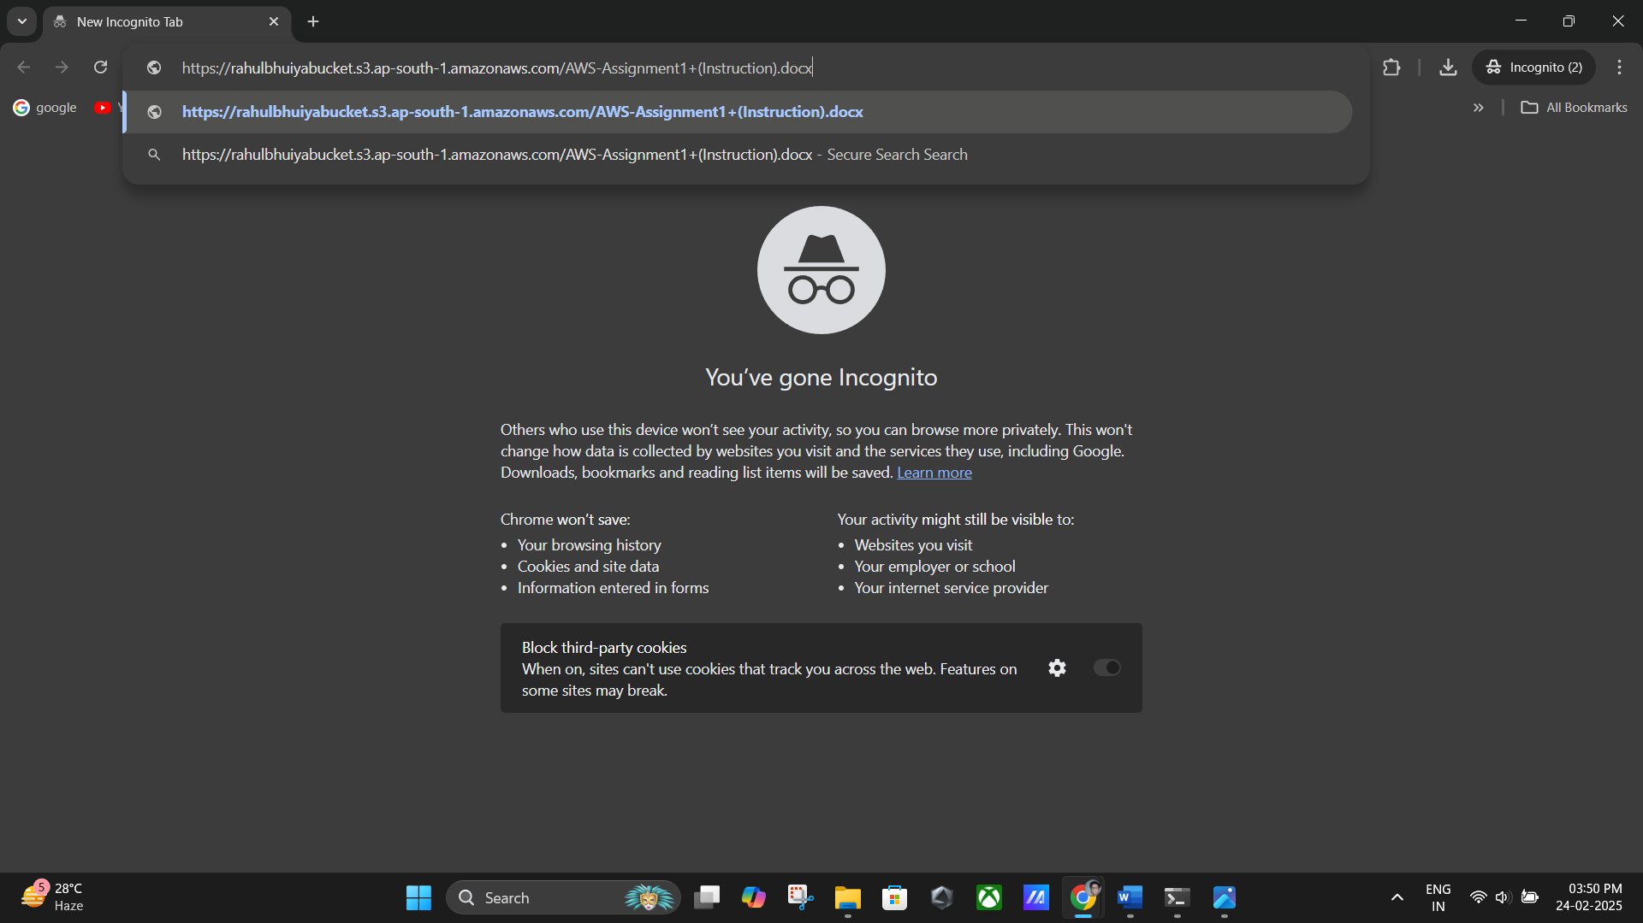If permissions are correctly set, the file should be accessible publicly.

**(Pasting The URL in Incognito Tab).**

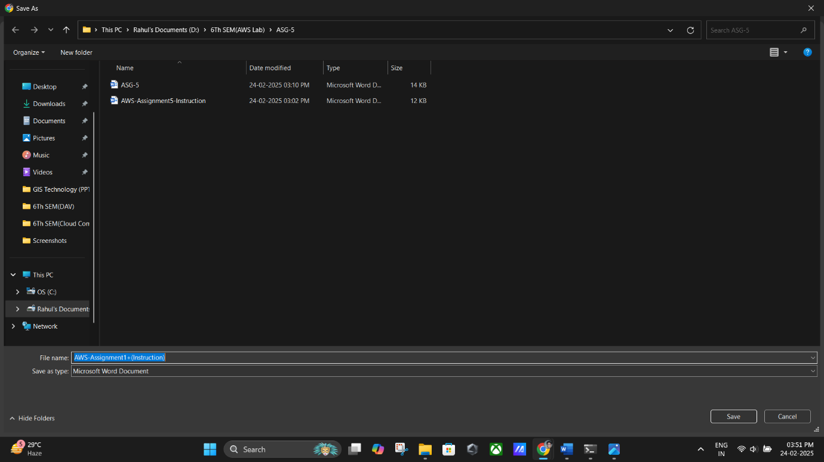

**(Downloading The Public Content).**

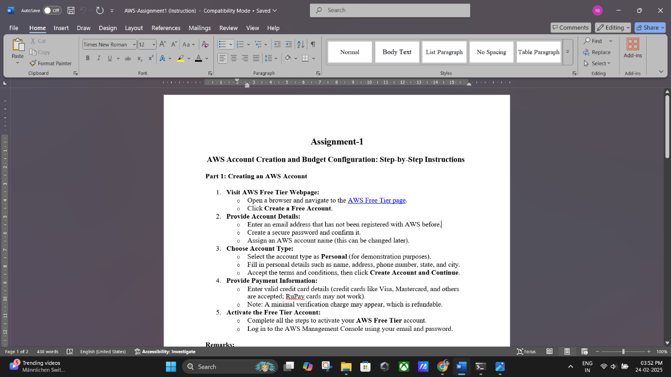

**(Successfully Downloaded the Bucket Content enabled Publicly).**

# Important Notes:

* Failing to edit the permissions under the ACL will result in access denial, even if the bucket is marked as public.
* Ensure the bucket name is unique across AWS.
* Publicly accessible files may expose sensitive data if permissions are not carefully managed.